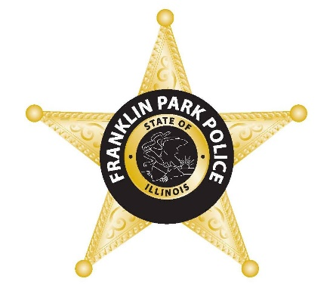

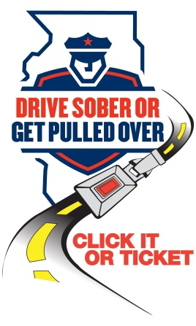
FOR IMMEDIATE RELEASE: May 16th, 2023
CONTACT: Director Michael Witz, mwitz@vofp.com

Franklin Park Police Department joins Illinois ‘Click It or Ticket’ campaign to save lives

[Franklin Park, Illinois] — The Franklin Park Police Department today announced it is stepping up enforcement for the Memorial Day “Click It or Ticket” campaign that will run May 19-30 and reminds motorists to buckle up for safety. “Click It or Ticket” leverages education and enforcement to save lives.

“Seat belts have proven to be life-saving in the event of a crash,” said Director Witz. “Unfortunately, many still don’t buckle up. Worse yet, not wearing a seat belt is a habit that can be passed on to younger generations who follow the example set by their elders.”

Memorial Day weekend marks the unofficial start of summer, a popular time for traveling to visit family and friends. Whether you are traveling down the block or across the country, make sure you buckle up every time. Wearing a seat belt can reduce the risk of fatal injury by 45%. Seat belts save lives every day, but they’re only effective if they’re used.

While Illinois currently has a 93% seat belt use compliance rate, unbelted occupants still account for more than half of those killed in motor vehicle crashes. The simple click of a seat belt could save thousands of lives each year.

The “Click It or Ticket” campaign is administered by the Illinois Department of Transportation with federal highway safety funds.
###
12879c-012417-v1a

